# Building a Run Chart Evidence Based Practice Workshop January 2020

**Rebecca Olson, Business and Social Science Informationist, Research & Data Services, UC Libraries. Langsam 401. 513-556-4657, Rebecca.olson@uc.edu**

**Step 1.** Open Excel. Enter your data into Excel Columns. Column A should be your time periods, Column B should be the data you collected. Give the two columns names and enter the data.

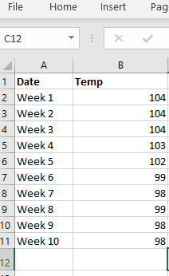

**Step 2.** Highlight all of the data by using your mouse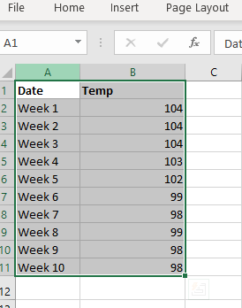

**Step 3**. From the INSERT menu at the top, select 2-D line with Markers.

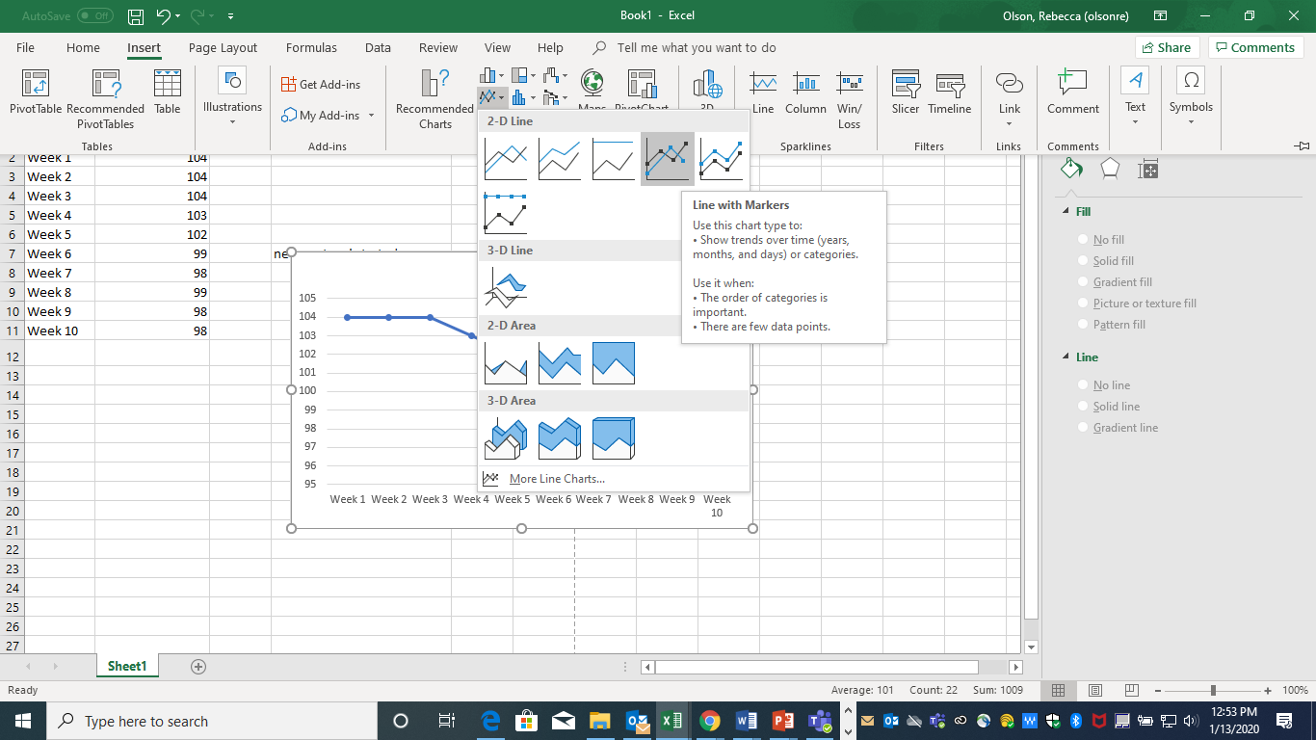

**Step 4**. You now have a basic Run Chart that you can format.

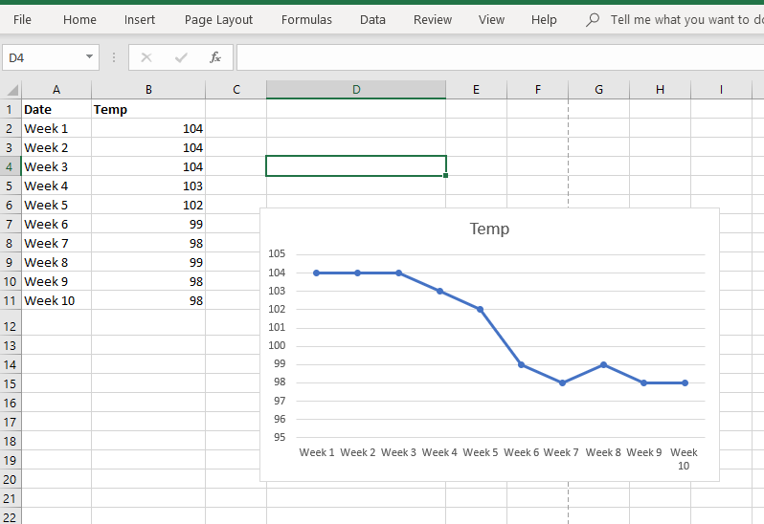

**Step 5.** Formatting depends upon what you want to do with your chart. Each version of Excel may have slightly different directions for formatting.

1. **Remove grid lines**. Since you may want to include a median line, you will want to remove the grid lines. Click on one of the grid lines and then hit “delete.”

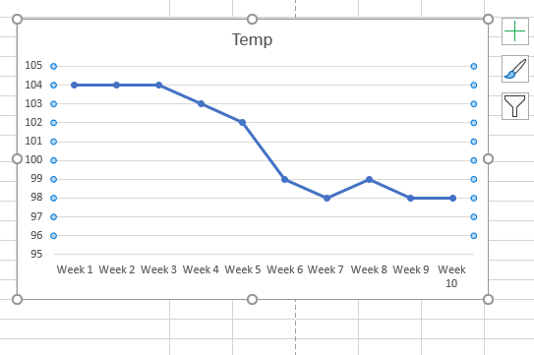

1. **Format the Vertical axis.** In this case, for temperature, you probably don’t need to change the range. But a good rule of thumb is to extend the range above and below the current range to include future changes. Some advise the data to be in the middle of the chart, some advise there to be 1/3 above/below of white space.
2. **Give your chart and your vertical axis a title**. Click where the title is and start typing. You can use formatting, add dates, etc. Make sure your vertical axis makes sense. Use the Design menu and add chart element for the Y and X axis.

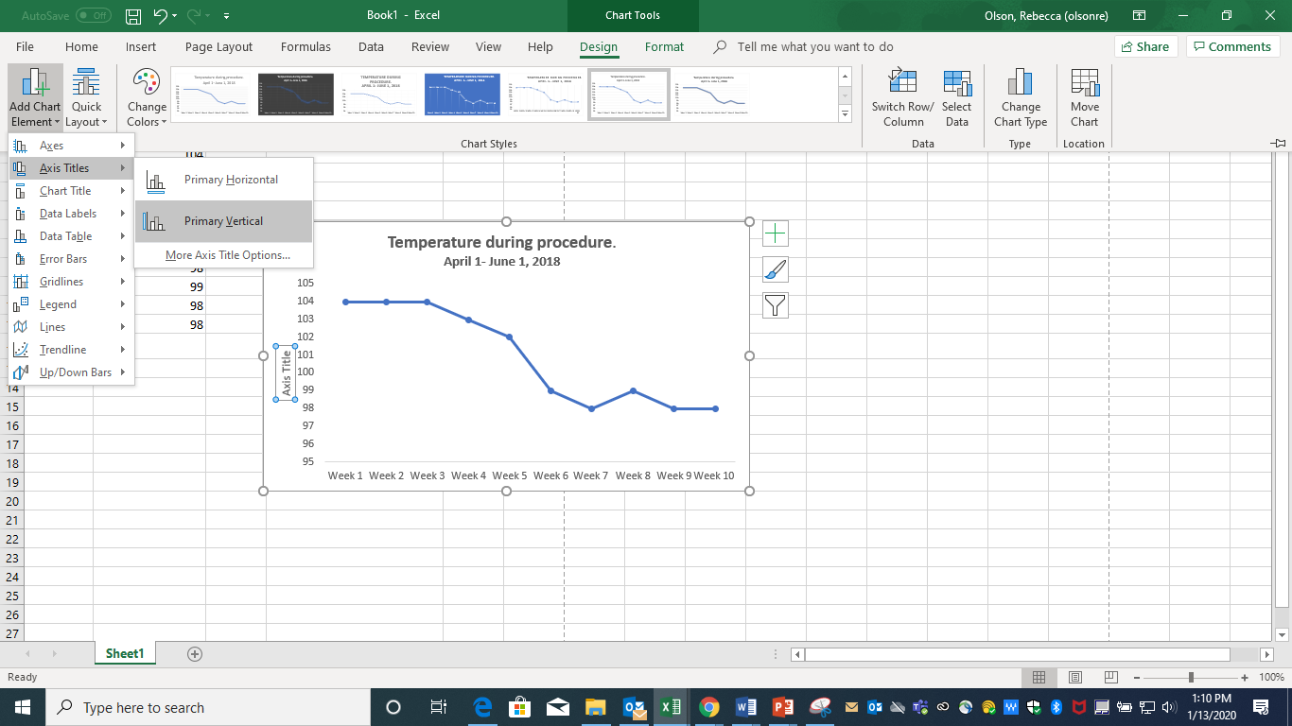

**Step 6.** **Add a median line**. In order for run charts to be analyzed, they require a median line. Most of the time, the line will be the median of all points being plotted. The median is the number in the middle if all the plot points were arranged from smallest to largest. You need to calculate the median of the plots.

Click on a blank cell in the spreadsheet (B13 in the image below). Type in **=median(B2:B11)** (or whatever the range of your points are). Click Enter. The median is 101.

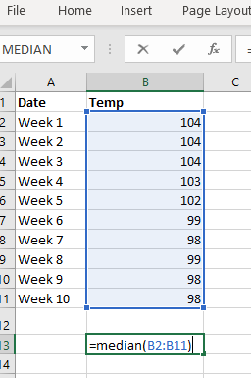

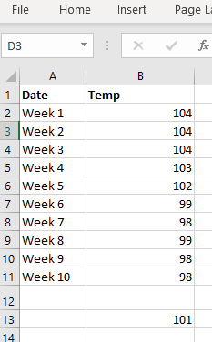

**Step 7**. Adding the median line to the chart. Name Column C **Median** and enter the value. Place the value in the entire column by dragging the **+**.

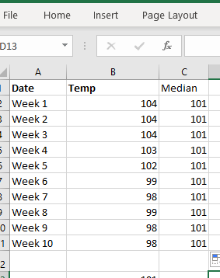

**Step 8.** Add the Median line to the run chart. Click on the graph. Note that Column A and B are highlighted. Drag the bottom right corner over column C. A new line will show up on the graph.

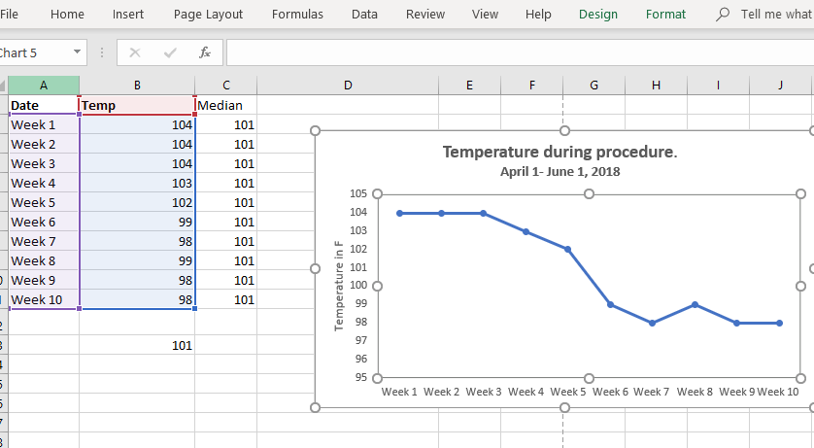

New Chart Line 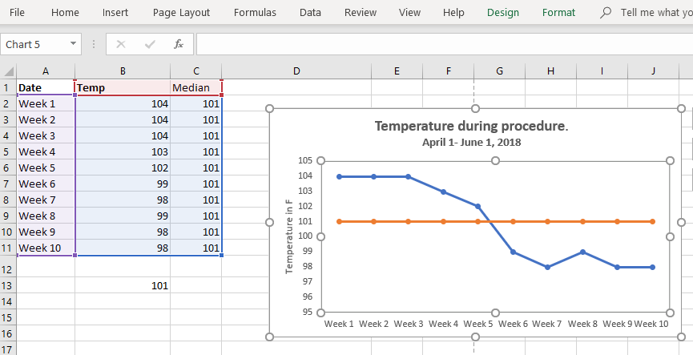

The median line should be smooth – so you will need to remove the formatted tick marks.

**Right click on the Median Line**. Chose “change chart style” and select the “plain line.”

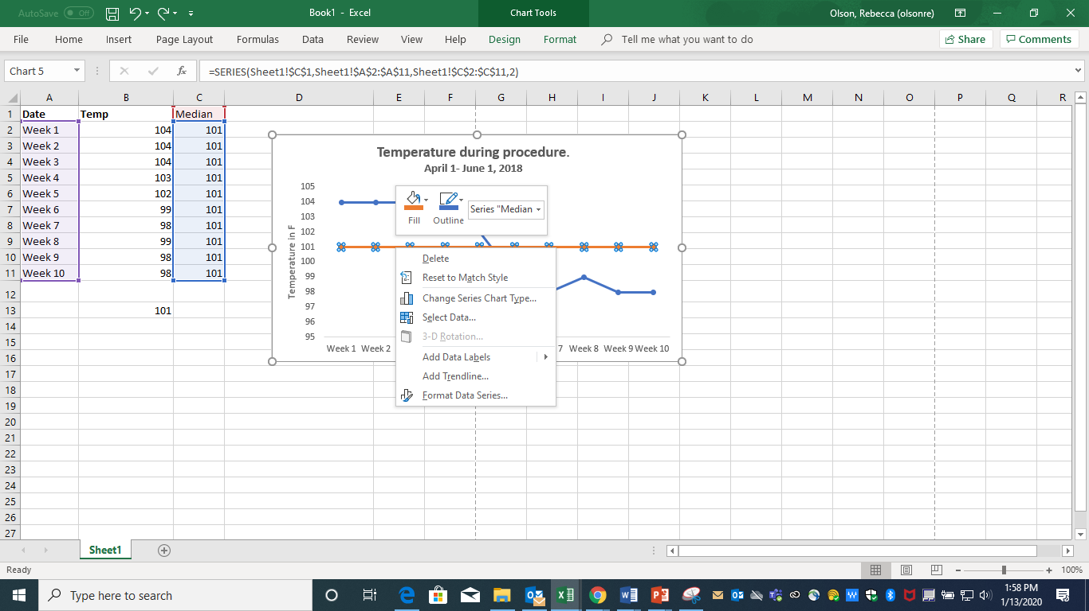

**Select Line (no markers) for the median.**

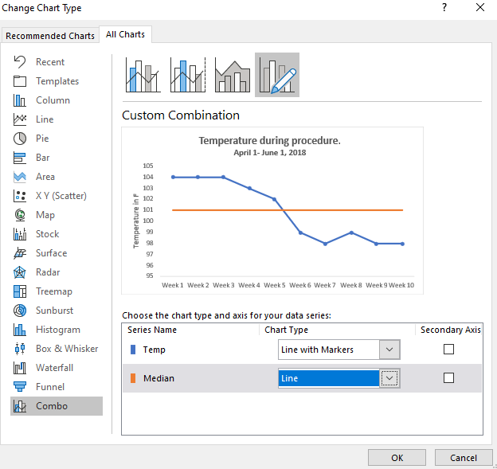

**7 steps in constructing a Run chart (adapted from Provost & Murray, 2011)**

1. State the question that will be answered. Start collecting the data
2. Horizontal Scale
   1. Usually a time scale in normal increments (hours, days, weeks, months, quarters, etc)
   2. Best practice tip: Label Future increments, even if you don’t have the data yet. Scale should cover future graph requirements, not just current data
3. Vertical Scale
   1. Make the vertical scale easy to plot, read, and remember to leave space for future data that may have significant range changes.
   2. Criteria for a good scale:
      1. Most data is located in the middle half of the graph
      2. Labeled values on the axis should be round numbers, equally spaced.
      3. Unlabeled tic marks should be easily read and plotted
      4. Ratio should be 2.5 Vertical to Horizontal
      5. Estimate range of data points to be plotted on vertical scale and develop vertical scale with high and low points enough for variation in data.
4. Plot
   1. Plot data points with a dot or another symbol
   2. You can connect the points with a line, but DATA is the DOTS, not the line
5. Label the graph completely with a useful title
   1. Horizontal scale – sequence of data (month, case, etc)
   2. Vertical scale – name of measure or characteristic being studied
6. Calculate the Median of the data
   1. Median (middle number of values) should be calculated from the data on the run chart and be placed on it.
   2. Can change median/add additional median if values plotted change significantly.
7. Additional Info
   1. Can add a goal or target line if appropriate
   2. Can annotate important events (treatment 1 started, change 2 on this date)

Resources used.

Anhøj J, Olesen AV (2014) Run Charts Revisited: A Simulation Study of Run Chart Rules for Detection of Non-Random Variation in Health Care Processes. PLOS ONE 9(11): e113825. <https://doi.org/10.1371/journal.pone.0113825>

Canadian Foundation for Healthcare Improvement (2014) How to Make a Run Chart in Excel

<https://www.cfhi-fcass.ca/sf-docs/default-source/on-call/22-10-14-how-to-make-a-run-chart-in-excel-cfhi-tutorials-en.pdf?sfvrsn=3ffdd44_2>

Oregon Association of Hospitals and Health Systems (2018)How to Make a Run Chart Using Excel

<https://www.oahhs.org/assets/documents/files/how-to-make-a-run-chart-using.pdf>

Provost, L. P., & Murray, S. (2011). *The health care data guide : Learning from data for improvement*. Retrieved from [https://ebookcentral.proquest.com](https://ebookcentral.proquest.com/) See especially, Chapter 3 on Run Charts

<http://uclid.uc.edu/record=b5782001~S39>